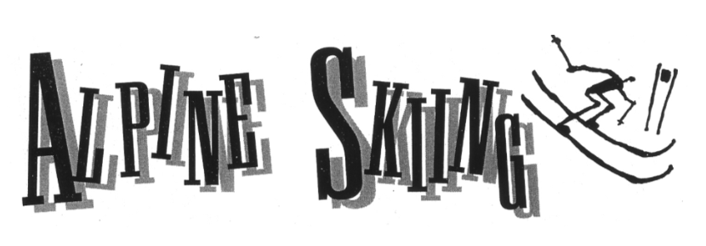

Skiers racing as fast as 80 miles per hour down mountain slopes make Alpine skiing one of the most exciting and daring sports of the Winter Olympics.
Alpine skiing got its name from a mountain range in Western Europe, called the Alps, where the sport began thousands of years ago. It has been a popular sport since about 1900, and organized races have been held since 1921. Some ski racing events were included in the 1936 Olympics, but it wasn’t until 1948 that Alpine skiing became a regular part of the Winter Games.
At the 1948 Olympics in St. Moritz, Switzerland, men and women each competed in three events: downhill, slalom, and combined. The Winter Olympics have also added giant slalom and super giant slalom events.
The downhill is fast, thrilling, and wide-open. Skiers race down a course that is about two miles long and marked with gates. They ski around the gates as they go down the mountain.
The word “slalom” is Norwegian for “slope track.” Skiers race down a course that is about a half-mile long, with gates that are close together. These force the skiers to make sharp turns.
The giant slalom (which which was added to the Olympics in 1952) combines the turns of slalom with the speed of downhill. The giant slalom course is about a mile long.
The super giant slalom, or Super G, also combines slalom and downhill, but the course is about 1 ½ miles long. Super G was added to the men’s program in 1988 and the women’s program in 1992.

**You Are There**

It is February, and you are standing in the starting gate at the top of the mountain for the men’s downhill competition. You are waiting to begin your first run in the Olympics.
You stare down the steep ski course. The start official begins the countdown.
“…four…three…two…”
You press your body forward, your weight supported for an instant by your poles. A thin fiberglass wand stretches across the gate in front of your knees. The wand is connected to a timer. When you blast off down the mountain, your legs push the wand out of the way and start the clock that times your run. You take three skating strides with your skis and push off with the poles. You are on your way.
The mountain is steep, and you accelerate quickly. You bend forward at the knees and waist and snap into an egg-shaped or “tuck” position to slip through the air. This position is very

aerodynamic, which means the wind slips past you and doesn’t slow you down as much. You pull your hands in front of your face and tuck your elbows tightly to your body. Your poles are tucked beside you. Your skis are flat and fast on the hard, icy snow.
You try to build as much speed as you can, and then not lose any of it on turns or jumps. By keeping your momentum, you will cover the distance from the starting gate to the finish line in the least amount of time. Races can be won by fractions of a second.
As you race down the mountain, you hold your tuck as long as you can, hitting speeds of 60 to 80 miles per hour. Any turn or break in form slows your momentum, and costs you time. Your only power source is gravity, and lost time is difficult to make up.
On the straightaways, you can keep your skis flat on the snow, gliding and gaining speed. On turns, the edges of the skis, which have been filed sharp, give you control. Skiing on the edges slows you down, so you snap back into your tuck and flatten your skis as quickly as you can.
The course is lined with crash nets and hay bales to catch you if you fall. But you know that if you fall, your race is over.
Less than two minutes after leaving the starting gate, you cross the finish line. You glance at the giant digital clock that displays your time for the 25,000 fans gathered at the base of the mountain.
You have skied at the Olympics and you have done your best. Now you must wait. More than 50 skiers from 25 countries will follow you down the course, two minutes apart, taking their turn at challenging the mountain.

>>Gear<<

Ski racers wear clothes and use equipment that makes them faster and protects them.
For speed, skiers in the downhill events use long, stiff skis that glide very fast over the snow. Because they are so long, the skis do not turn very well, but downhill skiers don’t have to make sharp turns.
Skiers in the slalom event use skis that are shorter and narrower. These skis are designed for the quick, sharp turns around the gates that slalom skiers need to make.
In the downhill and the super giant slalom, skiers use curved poles. When the skier is in a tuck position, the poles wrap around the skier’s body, reducing wind resistance.
For protection, skiers in the downhill and the super giant slalom events wear goggles and helmets. These helmets will protect a skier’s head in a fall at speeds of up to 100 miles per hour.
Skiers in the slalom and giant slalom events wear pants with padded shins, padded gloves, helmets, and face shields to protect themselves if they crash into the gates.
All downhill and Super-G skiers wear skin-tight racing suits. The suits are made of a slippery material to help them slip through the wind. A skier can be disqualified if a suit is too slippery. That rule is to prevent a skier from sliding too far if he or she falls.

