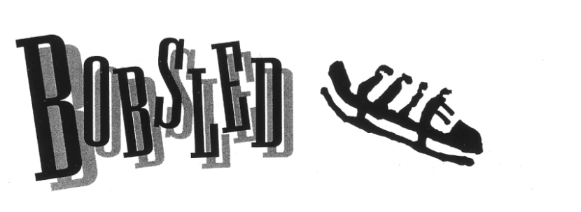

Bobsleds look more like miniature rockets than sleds. They are made of fiberglass and steel. They rumble down walled tracks as speeds of up to 90 miles per hour!
The track is actually a chute made of ice. It is 1,365 meters long—more than three quarters of a mile—from top to bottom, and it has 16 head-snapping twists and turns.
Bobsledding has a two-man event and a four-man event. A two-man bobsled team has a driver and a brakeman, and a four-man team has two additional crewmen.
The pull of gravity alone is what powers a bobsled down the track. Yet all through history, bobsledders have been looking for ways to go faster and faster.
Sled racing started in Switzerland in the late 1800’s. People on wooden sleds raced down ice-covered roads. The first bobsled track was built in 1904 in St. Moritz, Switzerland. Bobsledding was part of the first Winter Olympic Games in 1924.
In the early days, bobsledders got their sleds moving by sitting inside of them and rocking their bodies back and forth. This was known as “bobbing,” and it gave the sport its name.
Later, bobsledders tried using extra weight to make their sleds go faster. In 1948, the U.S. team sent to the Olympics a fast-sliding team of fat bobbers. The four team members weighed a total of 898 pounds. And they won the gold medal.
Four years later, the West Germans sent an even heavier team—1,041 ½ pounds—and they also won the gold. That led to a new rule, limiting a four-man team to a total of 880 pounds. A four-man team and sled can weigh 1,389 pounds and a two-man team and sled can weigh 859 pounds.
By this time, bobsledders were pushing their sleds to start them faster. In the 1960’s and 1970’s, several teams began to notice that the winning teams had the fasted start times. Teams began recruiting fast, powerful track and field athletes. Today, every top team in the world trains year-round to improve its starting time.
Each sled takes four turns down the track. Each run takes about 60 seconds. The times of all four runs are added together, and the team with the fastest overall time is the winner.
In bobsledding, medals are won by mere fractions of a second. In 1992, the gold-medal winner’s overall time in the four-man event was just a second faster than that of the seventh-place finisher.

**You Are There**

You are the driver in the four-man bobsled event. Your job is to drive a 1,380-pound sled down the track. If you make a mistake, your sled can flip over and slide down the track upside down. That’s why you are wearing a crash helmet.
Your sled is in the start chute at the top of the track. Earlier, you walked up the track to see every curve. Now it’s time to ride.
You take your position at the side of the sled, near the front of the cockpit. Your two crew members are on either side of the sled, and your breakman is at the back. Each of you is standing behind an arm that is attached to the sled. You will push on this arm to get the sled moving, and then fold it into the sled when you climb aboard.
A horn sounds and a light flashes on. This is the start signal. Your crew rocks the sled forward and backward to build momentum. On the third rock, you and your team blast off, running with spiked shoes over the ice, pushing the sled as fast as you can down the 50-foot-long starting chute.
When the sled crosses the starting line, it breaks an electronic beam that starts the clock to time your run. You jump aboard quickly, slide forward, and grab the two ropes attached to the sled’s two front runners. These are your steering handles. The two crewmen hop in, slide forward, and duck their heads. The brakeman jumps in last. Your team has given you a good start. Now it’s your job to drive down the track.
The track becomes steeper now and the sled moves faster. The turns come quickly. The sled reacts to the slightest pull on the steering handles.
You hit the first curve low, trying to take the shortest route, and this sets you up for the straight-aways. Your sled rumbles down the track like a thunderball. But you don’t hear the rumble, and you don’t see the fans who are standing near the track. All you see is a ribbon of ice in front of you. Everything else is a blur.
By the time you reach the bottom of the track, the sled is hurtling along like a bullet. The curves are banked steeply, some of them reaching 10 feet off the ground. On the last two turns, the sled is riding sideways to the ground!
You cross the finish line and your breakman yanks the brake lever that presses a steel claw into the ice. Your sled slides to a stop and you climb out. You see your time, and you and your teammates pass high-fives. This was only your first run. You get to take this wild ride three more times.

