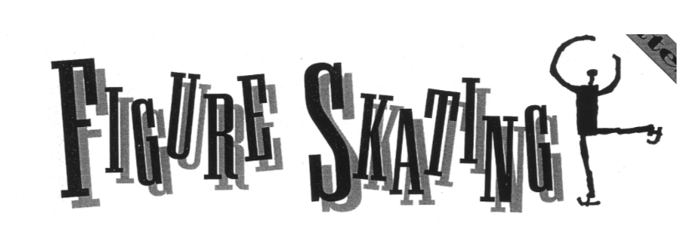

Figure skating has been part of the Olympics since 1908, when it was included in the Summer Olympics in London, England. In present time, skaters compete in the three events introduced at the 1908 Games: men’s singles, women’s singles, and pairs. They also compete in ice dancing, which was added to the Olympic program in 1976.
For many Olympic watchers, the men’s and women’s singles are the highlights of the Games. The winners of these events have included some of the most famous of all winter Olympians, including Sonja Henie [SON-ya HEN-ee], Katarina Witt [vit], Dick Button, Scott Hamilton, and Brian Boitano [BOY-tah-no].
Actually, “figure skating” is no longer an accurate name for the sport. In 1990, the sport’s officials eliminated the part of the competition called “figures.” In figures, skaters were required to trace precise patterns on the ice, such as a figure eight. Without the figures competition, skating has become more acrobatic and athletic.
The pairs event consists of teams of one man and one woman skating together. The pairs perform moves with difficult lifts and throws, in which the man throws the woman into the air, and she spins two or three times before landing.
Ice dancing is also performed by teams of one man and one woman. In ice dancing, however, overhead lifts and throws are not permitted. Instead, dancers are judged on rhythm, interpretation of the music, and precise steps.
Professional figure skaters were allowed to compete in the Olympics for the first time in 1994. Prior to that time, skaters who turned professional were banned from the Olympics.

**You Are There**

Your mouth is dry. Your nerves are frazzled. For 10 years, you’ve been training six to eight hours a day for this one chance to skate in the Olympics. Moments ago, your name was called over the loudspeaker at the ice rink. It’s your turn.
You step through a doorway and skate to the center of the ice. You feel as if you are floating.
Over the past year, you have performed your routine at least 100 times, perfecting dance steps and arm movements. You’ve fallen at least 100 times learning to make the five difficult triple jumps you will perform look easy.
Now you are standing alone on the ice. You remind yourself to smile. The 6,000 fans in the audience are watching you. Television cameras surround the rink, and millions more people are watching at home. Sitting rinkside are the most important people of all—the judges. All you have worked for in the past 10 years comes down to the next few minutes—4 minutes for women and 4½ for men.
And then the music starts, music you have selected. For the first time in hours you are back in a familiar world. You are performing your own routine to your own music, just as you have rehearsed.
The rules for the freeskating program are simple: You can do anything you want on the ice. What is difficult is performing moves that match the music, and doing it in a way that pleases the judges.
Your routine starts fast, with the music at a lively tempo. You sail around the rink, as if you are introducing yourself to the audience. In the first minute, you perform three of your five jumps, including the most difficult, a triple Axel. And you nail it! Your confidence soars as the audience roars its approval.
Quickly, the music changes. The tempo slows and so does your skating. This is a difficult section of your routine because you must entertain the audience with mostly footwork, spins, and graceful arm movements, and with only a few leaps and jumps.
And then the music changes again. The tempo picks up, and your skating becomes quick again. In this final minute, you create excitement with your last two jumps. You stumble on the second, but you recover.
And then it’s over. The crowd cheers loudly as you glide off the ice. Some fans throw you flowers. Your coach gives you a hug. An official leads you to an area next to the ice, where you will sit with your coach and wait for the judges to post your score.
You have done your best, and you are happy. Now it is up to the judges.

~The Rules~

SINGLES: Men and women each perform two different programs. The first is called the short program, and it is worth one-third of a skater’s score. The second program is called the long program, or freeskating program, and it is worth two-thirds of a skater’s score.
The short program must be less than 2 minutes 40 seconds long, and it is performed to music selected by the skater. Each skater’s routine must contain eight moves: three jumps, three spins, and two footwork moves.
The freeskating program lets a skater be creative. Skaters select their own music and costumes and they create their own routines. Routines are designed to show off both a skater’s athletic ability (to jump high and perform difficult moves) and artistic ability (to show footwork and artistry).

PAIRS: Each program consists of two routines: the technical program, which counts for one-third of the score; and the freeskating program, which counts for two-thirds.
In the technical program, each pair selects its own music and performs for no more than 2 minutes 40 seconds. Each program must have eight required moves, including spins, side-by-side jumps, and overhead lifts.
The free skate program lasts 4 ½ minutes. Each pair selects its own music. Skaters are judged on difficulty of movements, teamwork, and how artistically they present themselves.

DANCE: The ice-skating competition is made up of three parts: the compulsory dances, which are worth 20 percent of the score; the original dance, which is worth 30 percent; and the free dance, which is worth 50 percent.
The compulsory dances are probably the most difficult and least interesting part of ice dancing. All the pairs must perform the same two required routines to the same music.
In the original dance, the skaters are given a type of dance, such as a waltz or a tango, and they must create their own two-minute version of that dance. In the free dance, skaters have 4 minutes to perform the most original dance they can create. Skaters can choose any beat or rhythm. They are encouraged to invent original movements and steps.

SCORING: Skaters perform before a panel of judges. Each judge gives each skater or pair two marks: one for technical merit and one for artistic merit. The technical mark tells how well each skater performed his or her moves. The artistic mark is for style, grace, ease of movement, and how well the skater interpreted the music.
The judges’ scores are not added together to figure out who won. Instead, each judge’s scores are used to rank each skater or pair according to how the judge thought that performance compared to those of the others skaters or pairs.

