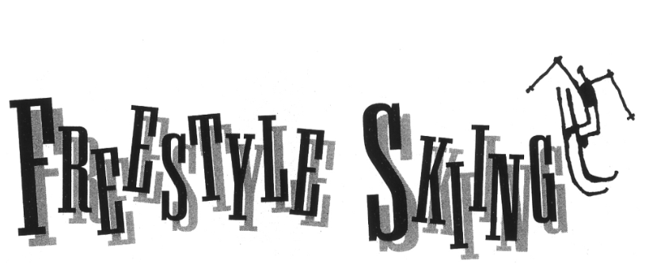

The two freestyle skiing events, moguls and aerials, are the trapeze and highwire acts of the Winter Olympic circus.
Freestyle skiing is a relatively new sport. In the 1960’s, some downhill skiers became bored with simply sliding down a mountain. So they began “hotdogging,” jumping into the air off bumps or mounds of snow called moguls, and doing wacky tricks and flips. In 1979, freestyle became a World Cup event, and in 1988, it was a demonstration sport (no medals were awarded) at the Calgary Olympics.
In 1992, men and women competed for Olympic medals for the first time in a freestyle event: moguls. Four countries—the U.S., the Unified Team, France, and Norway—won the six medals that were awarded. The aerials event was added to the Olympics in 1994.

MOGULS: In the Olympics, skiers ski one at a time down a steep section of mountain that is covered with moguls. This is called the mogul field.
Loud rock music accompanies the skiers, as they ski over or around some moguls and do wild jumps off others. Judges score each skier’s run, and the high and low scores are dropped. Skiers are judged in three areas:
- Speed: Worth 25 percent of the total score. Skiers try to pick as straight a line as possible to go down the mogul field. Skiers travel 25-30 miles per hour and finish a run in less than 40 seconds.
- Turns: 50 percent of the score. Skiers must be aggressive, but under control. During turns, the skier’s upper body should face down the hill. The skiers should use the tops, sides, and bottoms of the moguls during turns.
- Jumps: 25 percent of the score. At two points during a run, a skier must fly into the air off a mogul and perform a trick, such as spreading his arms and legs apart. The skier must perform a different trick on each jump. The jumps are scored on the height of the jump, difficulty of the trick, and how well the trick is performed.

AERIALS: Aerial skiers fly into the air off ramps and perform difficult flips and twists. An aerials course is a carefully constructed launching pad. The skiers start at the top of a steep slope called the in-run, which is about 66 yards long. The skiers reach speeds of about 35 miles per hour on the in-run. At the bottom of the in-run is a short, steep ramp called the kicker. The kicker launches the skier as high as 50 feet into the air.

Each skier performs two different jumps. Judges score each jump based on takeoff, worth 20 percent; form in the air, worth 50 percent; and landing, worth 30 percent. In addition, each type of jump is assigned a degree of difficulty. That is a number based on how hard the trick is to perform; the harder the trick, the higher the number. The judges’ points are added together, and this total is multiplied by the degree of difficulty. The scores from the two jumps are added together for a final score.
An extremely difficult jump is the quad-twisting-triple. The skier does four 360-degree twists and three complete flips before landing. This trick has a degree of difficulty of 4.45.

**You Are There**

Who would have thought you would make it to the Olympics? You have always loved skiing, but you were never the fastest down the mountain. You enjoyed the bumps and jumps.
In 1988, moguls became an Olympic demonstration sport. You entered local competitions. Improvement came quickly. In 1992, you watched on TV as the first Olympic moguls medals were awarded.
And now here you are, in the starting chute at the top of the moguls field at the Olympic Games. At least 10,000 people are watching at the bottom of the run. Giant loudspeakers blast continuous music. You skied well enough in the preliminaries to reach the final, and now you are all set for your run.
Boom! You are out of the starting gate quickly, and you are right into the moguls. As you make your turns, you keep your weight centered over the skis.
You hit the first of your two jumps. Staying in control is the key. Your timing is perfect. You lift your arms and legs into a move called a spread eagle. Your legs come back together just before you land.
Immediately, you are juking and weaving again. The judges are watching. Your second jump is coming up. You fly off the bump, twist your body to the left all the way around, 360 degrees. It’s a difficult move called a helicopter. You had considered doing something simpler. But as your mogul buddies say, “Go big or go home.”
Your landing is a little shaky, but you recover and don’t fall. You lose a couple of style points but you are thrilled anyway. A couple more turns, and the run is over. You throw your arms up into the air. You did it!

