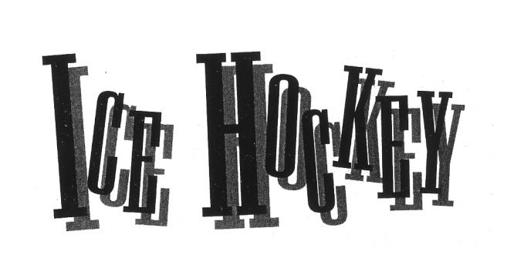

If you like to turn on National Hockey League games to watch the goons slug it out, don’t bother watching the Olympic hockey tournament. Hockey has been called the world’s fastest game, and Olympic hockey players rarely slow down to fight.
Olympic hockey is played on a rink that is 200 feet long and 100 feet wide, which is about 15 feet wider than an NHL rink. The larger rink means that there is more room to skate, and this gives an edge to teams with fast, agile skaters who can handle the puck like magicians. Heavy-hitting teams that like to fight are usually left behind in the breeze.
Teams from Canada and the United States generally have NHL-style players who like to hit and pound on their opponents. On the other hand, the players from the European countries, especially Russia (which was part of the Soviet Union until 1988 and then part of the Unified Team in 1992), are among the fastest skaters in the world—and also big enough to get tough when necessary.
In the final game of the 1992 Olympics, Canadian players tried to rough up the players from the Unified Team. The Unified Team players simply ignored the Canadians by turning and skating away from trouble. The Unified Team won, 3-1.
Regardless of style of play, the objective for all the Olympic teams is the same: to put the puck into the opposing team’s goal. Teams are made up of a goalie, who guards the 4-foot by 6-foot goal, and five players who skate up and down the ice. Those five are the center, two forwards, and two defensemen.
The center stays near the middle of the ice and runs the team’s offense. He sets up plays and passes the puck inside, much the way a point guard runs the offense for a basketball team. The forwards, or wings, stay near the wooden boards that surround the ice, although they often cross the ice to confuse the defense. The defensemen help the goalie protect the goal, though they also will skate into the offensive end.
Teams play three 20-minute periods, each separated by a 15-minute intermission. Hockey players must be in excellent physical condition because they skate very fast and hard. But no player can skate hard for a full 20 minutes. So each team is divided into several smaller teams, called lines. A line is made up of a center and two forwards.
Teams change lines every minute or so to keep fresh legs on the ice. Teams do not have to wait for the game to stop to change lines. Players usually scramble back and forth over the

boards to enter or leave the game whenever the puck is in the other team’s offensive end of the rink.
Only 12 teams qualify for the Olympic tournament: the host team, the winner of the Olympic qualifying tournament, and the top 10 finishers from the world championships. The 12 teams are divided into two groups of six teams each. Teams in each group, or pool, play the five other teams in their pool. The four best teams from each pool advance to the final round. The eight teams in the final round play each other to determine who will win the medals.

**You Are There**

You are the goalie for the United States team at the Olympics, and you know what the American people expect from your team. Ever since 1980, when the U.S. won the gold medal in hockey, the American people have been waiting for the U.S. to bring home the gold again.
Your home for the hockey tournament is in an area in front of the net, called the crease. The crease is a half-circle with a radius of six feet. You stay in the crease and try to keep the other team from hitting the puck past you and into your team’s goal. As long as you stay in your crease, opposing players are not allowed to bump or hit you intentionally.
Protecting the goal is not an easy job. Players can hit the puck so hard that it zooms at you at more than 100 miles per hour. The puck skips and bounces at crazy angles, testing your reflexes. Sometimes it seems to bounce from player to player like a ball in a pinball machine.
You wear about 40 pounds of equipment to protect your body from the force of the puck. The pads on your legs and arms are wide, so you can use them to block the puck. On your head is a helmet. Over your face you wear a hard plastic mask that is painted red, white, and blue. In the 1960 Olympics, goalies didn’t even wear masks! You don’t want to imagine how it would feel to have the hard puck slammed into your face.
The first game of the tournament starts slowly. Midway through the first period, the other team sets up its offense. The center fakes a pass to a forward, and then takes a slop shot from 30 feet out. The blade of his stick has a slight, ½-inch curve. This puts a spin on the puck that causes it to rise and dip.
You reach up by instinct when you see the shot, and you catch the puck with the glove on your left hand. The glove resembles a first baseman’s mitt in baseball. You drop the puck and tap it with your wide-bladed stick to one of your defensemen. He clears the puck from the net area and passes to your team’s center. The center heads up-ice. Your team is now on the attack.
A few seconds later, the action flashes right back toward you. A player from the other team has stolen the puck, and he’s on a breakaway. That means he’s gotten past the defensemen and is coming right at you, one-on-one.
This is a goalie’s worst nightmare.
The skater is closing fast, just to your left. You move toward him, away from the net. This is called “cutting off the angle.” It gives the player less room to shoot the puck past you and into

the goal. The player fakes to your left, but you don’t bite. Your glove hand is at your left side, about chest high. In your right hand, you hold your stick with the blade directly in front of you.
The skater makes a sharp cut to your right. You try to stay between him and the goal, but he’s very quick. He shoots, and the puck hits your leg pad. You try to cover the puck after it falls to the ice in front of you, but it bounces too far away and your opponent pokes it clear with his stick. He shoots again, and you dive to block the shot. This time, the puck slips under your arm and skips into the net. Goal!
Ooh! You’re mad at yourself. But you’re also mad at your defensemen for letting the scorer get behind them. Your teammates skate past and tell you not to worry.
“We’ll get it back,” they say.
Your team does score two goals in the second period, and you give up one more goal early in the third period. As the final period winds down, the score is tied. You have played a strong game. The other team’s offense has been on the attack all day, and you have blocked 30 shots on goal.
Now the pressure is really on. There are two minutes left to play. Your team needs this tie; it cannot afford a loss. The other team is swarming your net, shooting so often that is seems as if there are five pucks on the ice. You block one shot, and then another one.
Suddenly, you feel the weight of the expectations of all those people watching on television at home. You put that out of your head and concentrate. Only one more minute to go, and you’ll be that much closer to reaching the medal round!

~The Rules~

The rules of Olympic hockey are similar to those of the NHL. The rink is divided by a red line at mid-ice, and by blue lines on either side of the center line. If a player is moving toward the other team’s goal, and he crosses the blue line in his offensive zone ahead of the puck, the officials call offside and hold a faceoff. A faceoff is like a jump ball in basketball, except the official drops the puck instead of throwing it into the air. Icing is called when a player hits the puck from one end of the ice to the other without it touching another player.
Even though there is almost no fighting in the Olympics, players are permitted to skate into opponents to knock them away from the puck. This is called checking. But players are not permitted to hit another player with a stick. Officials can call fouls for hitting an opponent with the butt-end of the stick, cross-checking (holding your stick across your body as you hit an opponent), slashing (swinging the stick as a weapon), and high-sticking (lifting the stick above your waist to hit an opponent). Raising your stick above your shoulder to swat at a flying puck is also called high-sticking and is also a foul.
For committing a foul, a player is sent to the penalty box for two minutes. His team must play with four players and a goalie. The other team, with one more skater, is said to be on a “power play”.
Players can receive a five-minute major penalty for serious fouls, such as trying to hurt an opponent with a cross-check. And any player who starts a fight is kicked out of the game.

