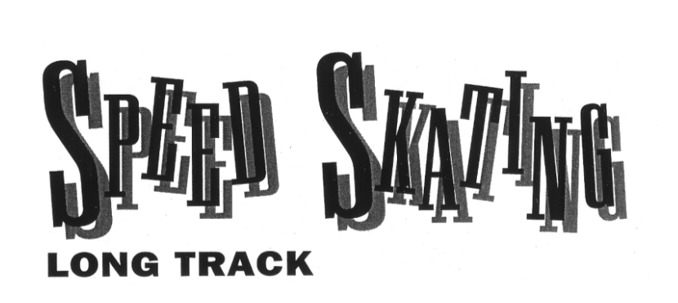

Long-track speed skating was the first competition at the first Winter Olympics, which were held in Chamonix, France, in 1924. And the first race ever held in the winter games was won by an American!
In the 500 meters, Charles Jewtraw of the U.S. won the gold medal in an upset over skaters from Norway and Finland, two countries in which speed skating is a national sport. Skaters from those countries swept the medals in the remaining three events: the 1,500 meters, 5,000 meters, and 10,000 meters.
The sport of long-track speed skating has not changed much since 1924. Skaters still race two at a time, side-by-side, around a 400-meter oval of ice. Their goal is still to skate as fast as possible. In long-track speed skating, unlike in most racing events, there are no trials or heats. Skaters get one chance in each event, and the fastest skater wins.
Each pair of skaters races against the clock, not each other. Skaters stay in their assigned lanes. But because the distance around the track is shorter on the inside lane than on the outside lane, skaters change lanes on the backstretch of each lap to make the race even.
Two things have changed in long track since Charles Jewtraw’s first race. For 36 years, women were not allowed to compete in speed skating at the Olympics. Finally, in 1960, women’s races were introduced at distances of 500, 1,000, 1,500, and 3,000 meters. The women’s 5,000 was added in 1988. Also, a men’s event, the 1,000, was added in 1976.
Another change is that skaters have become more specialized. In 1980, Eric Heiden won five gold medals at distances that ranged from 500 meters (a sprint he did in 38 seconds) to 10,000 meters (a distance race he finished in 14 minutes 28.13 seconds). And in 1964, Lydia Skoblikova of the Soviet Union won four races from 500 meters to 3,000 meters. These performances will probably never be matched because, today, most top skaters specialize in either sprint (500 and 1,000 meters) or distance (5,000 to 10,000 meters) events.
Sprints require explosive speed, while the distance races require endurance and stamina. Because of more scientific training, skaters have gotten so fast that it is very difficult to train and compete in both.

**You Are There**

The 5,000-meter long-track competition is underway, and you are next to race. You pull the hood of your racing suit over your head. Your suit is made of a stretchy material called Lycra. It fits super tightly so the air will slip past you smoothly and save valuable fractions of a second.
Next, you wipe away any ice that may have formed on the 17-inch-long blades of your racing skates while you were warming up. You want the blades clean and sharp so they glide smoothly over the ice but don’t slip on the corners. Then you move into position on the track.
The starter gives you three commands. When he says, “Go to the start,” you slide to the starting line in your lane. When he says, “Ready,” you crouch into your starting position. At the gun, you blast off the line, driving your skates against the ice, swinging your arms forward and back, building up speed as quickly as possible.
This is a long race, 12 ½ laps around the track. It will take you about 6 ¾ minutes to finish, so you settle into your pace as you come out of the first turn.
You lean forward at the waist so that your back is almost parallel to the ice. This reduces wind resistance.
Your arms and legs all work together. As the skate on one foot pushes to the side to drive you forward, the other skate glides over the ice. The knee of your gliding leg is bent at about a 90-degree angle. Your right arm swings with the rhythm of your left leg. Your left arm is kept close by your body, with your left hand resting on your back.
You have trained as much as five hours a day to prepare for this race. Most of the training was very hard, to build your strength and endurance. But you also have worked very hard to perfect your technique and form. You have practiced your technique so often that skating seems as natural as walking.
As you head into the back straightaway, you continue swinging your right arm. Halfway down the backstretch, you cross over from the inside lane to the outside lane. You will skate one lap in this lane, and then change back to the inside lane.
Long-track speed skating is hard because you have no one to race against. Although there is another skater in the lane next to you, both of you are really racing against the clock. There are more than 30 skaters in this event. Your goal is to skate faster than any of them.
Your coach stands at the end of the back straightaway. At practice, the two of you had decided on the lap-by-lap pace you needed to keep to do your best in this race. You don’t have time to look at your watch, so as you come around on each lap, he gives you hand signals to let you know if you are skating too fast or if you need to quicken the pace.
For the first 10 laps, you are flying. But speed skating is a grueling sport and you begin to get tired. Your back begins to stiffen. Your leg muscles cry out for a rest. It is even hard for you to hold your hand behind your back.
Your coach is shouting encouragement. The crowd is cheering. It’s all up to you. You don’t know if your legs can push one more time. You don’t know if they can even hold you up. One more lap. Can you hold on? Of course you can! This is the Olympics.

