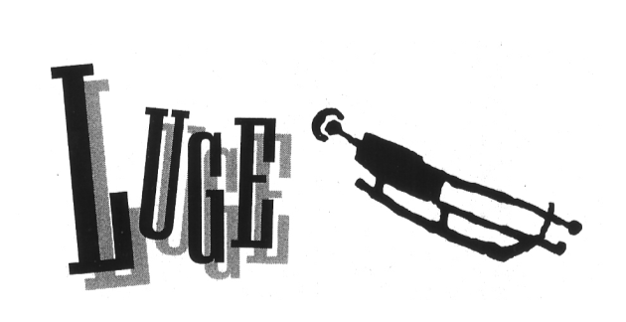

The word luge [LOOje] is a French word that means sled. The French sure have a funny sense of humor. A luge is not a sled. A luge is an ice rocket, and a ride on one is wilder than a ride on the world’s wildest roller coaster. You lie on your back on the luge and blast down a refrigerated ice track, twisting around curves at 75 miles per hour.
Daredevil athletes have competed in organized luge races since about 1880. But for many years, the sport was considered too dangerous to be part of the Olympics. Luge didn’t become an Olympic sport until 1964.
The goal in luge is to slide down the track as quickly as possible. There are singles competitions for men and women and doubles competition for men. (In doubles, two male lugers ride together on a slightly larger sled.) Each singles competitor takes four runs, and each doubles team takes two runs. The lugers (or sliders, as they are often called) with the best combined times win.
Sliding fast is a science and an art. There is no steering wheel on a luge, so the slider steers by leaning with his head, shoulders, arms, and legs. These movements are slight—sometimes simply tightening an arm muscle is enough to adjust the sled’s position.
To keep up his speed, the luger tries to keep the sled low in the curves and away from the walls on the straightaways. Every time the luger bumps a wall or rides high on a curve, he adds fractions of a second to his time. That can be the difference between winning a gold medal and no medal at all.
Five countries have dominated the luge event since it became an Olympic sport. Sliders from East Germany, Germany, Austria, Italy, and the Soviet Union have been the most victorious.

**You Are There**

A luge run lasts only about 45 seconds, but getting dressed for it takes a long time. First, you put on one or two thin layers of clothing—long underwear, socks, a T-shirt, maybe a turtleneck. Next you climb into a rubberized suit that makes you as slick as a missle. You pull

boots that look like ballet slippers over your feet, and then you put on a crash helmet with a full face-shield. Finally, you put on your gloves, which have metal spikes attached to the fingertips.
Whew! Now you’re ready to slide.
You are sitting on your luge in the starting chute, getting set to take the second of your four runs. You stretch your feet straight in front of you, beyond the curved-up ends of the sled’s runners, and grip the two handles that are part of the starting chute with your hands. A green light blinks on to tell you to begin your run.
To get a quick start, you rock your luge back and forth a couple of times to build momentum. Finally, you press back as hard as you can, and then you pull forward on the handles with all your might. Your luge shoots forward, and drops into the track. You paddle as fast as you can, pushing yourself forward, using the spikes on your gloves to grip the ice.
The starting chute is about 50 feet long. At the end of it is an electronic eye. Your run doesn’t officially begin until you break the beam from the electronic eye. You lie flat on your back and tuck your hands under your hips. Your toes are pointed, your head is back. You are on your way!
The first curve is a sweeping left. You take it low, which is the shortest, fastest way to go. A short straightaway is followed by another left turn, and then immediately a hard right U-turn.
You are moving faster and faster, with no time to think. You can’t even look up; you just react. You drop your shoulder and turn your head slightly. That movement is enough to make the sled whip through a turn. You try to relax and let your body absorb the bumps. You hit the straightaway dead center, away from the walls. Perfect!
The luge moves through a couple of slight curves. You feel yourself moving at 60 miles per hour! Bang! A U-turn left. Whip! A U-turn right. Your speed is up to 70 miles per hour. Your head is only four inches from the ice! The turns get tighter and tighter. You keep your head back. The force of gravity tries to spin you high on the track. You fight to stay low, leaning left on the final sweeping left turn.
You zip into the final straightaway. At 75 miles per hour, the bumps rattle your body. And then, suddenly, it’s over. You slide across the finish line and sit up. You pull up on the front of the luge, digging the ends of the runners into the ice, to stop.
Your run was a good one. You’re anxious to see your time. Tomorrow, you will be back for two more slides down the track.

