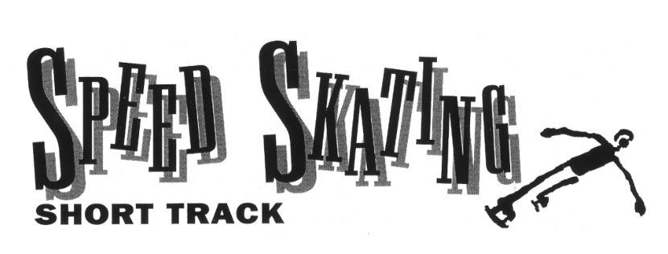

Put four very fast speed skaters on a tiny track with tight corners and watch what happens. The skaters bump into one another. They jostle for position. They sprint madly for the finish line. And they crash so many times that the wills at the ends of the rink must be padded so no one gets hurt.
This wild sport is called short-track speed skating. It is also known as pack racing or indoor racing.
In long-track speed skating, skaters race around a 400-meter track. In short track, the track is just 111 meters around the outside edge of a hockey rink. Skaters must advance through qualifying heats, quarter finals, and semifinals. The four skaters who survive race in the final. And unlike long-track, short-track skaters race against each other instead of against the clock.
Skaters race in groups of four to six. They usually stay in a pack until the end, when each skater tries to outsprint the others to the finish line. To protect them when they fall, skaters wear helmets, gloves, and kneepads.
There are two individual short-track events each for men and women: at 500 meters and at 1,000 meters. Racers also compete in four-person relays (5,000 meters for men and 3,000 meters for women). Unlike relays in running races, a skater can take over from a tiring teammate at any time during the race. The only rule is that the anchor (the fourth skater) must skate the final two laps.
Short-track skating was introduced to the Olympics in 1988 as a demonstration sport. It became a medal sport in 1992.
The sport may be new to the Olympics, but it is not new to U.S. skaters. Because there are so few 400-meter tracks in the United States, most American skaters, including Olympic long-track gold medalist Bonnie Blair, began their careers as short-track racers.
Short track is actually not even new to the Olympics. In 1932, the Games were held in Lake Placid, New York. Olympic officials decided to Americanize the speed-skating rules. They changed all four of the events, which then were open only to men, to pack style. Some European skaters, who had never raced in packs, refused to participate. As a result, skaters from the U.S. and Canada won 10 of the 12 medals.

**You Are There**

The starting gun for the 1,000-meter race has just fired, and you are one of four skaters to reach the final. You are on the tips of your blades, sprinting as hard as you can. All you hear is the sound of skate blades digging into the ice. Crunch. Chip. Crunch.
All four of you sprint madly, fighting for position before you reach the turn. The corner of the rink is less than 20 yards away.
You don’t want to be first into the corner. This is a long race, a bit more than nine laps. You would like to let the others break the wind resistance so you can save energy by drafting.
But what you really want to do is avoid crashing. All four of you try to squeeze into the tight corner at once. You are bent low at the waist, and your arms swing from side to side. Your arms help power your legs, and they help protect you from the other skaters. You get nicked from behind and stumble. But you keep your skates under you and slip into third position as you turn into the corner.
You are going about 25 miles per hour when you hit the turn. You lean left, so far that you reach down with your left hand and touch the ice.
As you come out of the corner, all four of you are in a line, so close together that you look like one skater with four pairs of legs. You are not concerned about lap times or your position. Right now you just want to stay close to the others.
Six laps into the race, the skater in the back decides to make a move. On the backstretch, he drops to the inside and sprints. You and the two other skaters react, and begin sprinting instantly. You catch up to the fourth skater with a few powerful strides. You now have a new leader. The pace slows, and you are in fourth position.
With one lap to go, you decide to make your move. You sprint wide and are forced outside on the curve. You drive hard down the backstretch. The others begin to sprint, too. All four of you are bunched together as you hit the final curve, with no clear leader. You are on the outside coming out of the curve, but you have a clear line to the finish line. Your legs burn, your arms swing hard from side to side.
The finish line draws closer. All you can hear is the sound of steel blades against the ice. Crunch. Chip. Crunch.

